Experiment #3 – Periodic Signal Spectra

# Youssef Samwel

# [yo800238@ucf.edu](mailto:yo800238@ucf.edu)

# EEE3352 Signal Analysis and Analog Communications

Section 0012

# Due Date 10/3/2023

# **Project Description**

The objective of this experiment is to introduce and explain the trigonometric and exponential Fourier series to the students and to understand the relationship between time waveforms and frequency spectra.

# **1.5 About Laboratory Day and Equipment List**

# The laboratory session took place on the Tuesday section between 8:00am and 11:00am on September 26, 2023. My lab partners were Joahn. The equipment for the is experiment is listed below,

1. USB Flash Drive
2. Rohde & Schwarz RTM 3034 Oscilloscope
3. Tektronix AFG3022 Function Generator

# **2.0 Pre-Lab Questions**

1. Find both the trigonometric and the exponential Fourier series expansion of the signal f(t) in Figure 3.9. Plot amplitude verses frequency for the signal. Identify the first three harmonics and their amplitudes. Find the power content from the time domain representation of the signal and from the first three harmonics of the Fourier series expansion, and make appropriate remarks.

2. What is the difference between an energy signal and a power signal? Give two examples of each.

An energy signal is finite whereas power signal is infinite because of its repattive nature. An example of an energy signal is a voltage waveform of a discharging capacitor, whereas an example of a power signal is a sinusoidal AC power source.

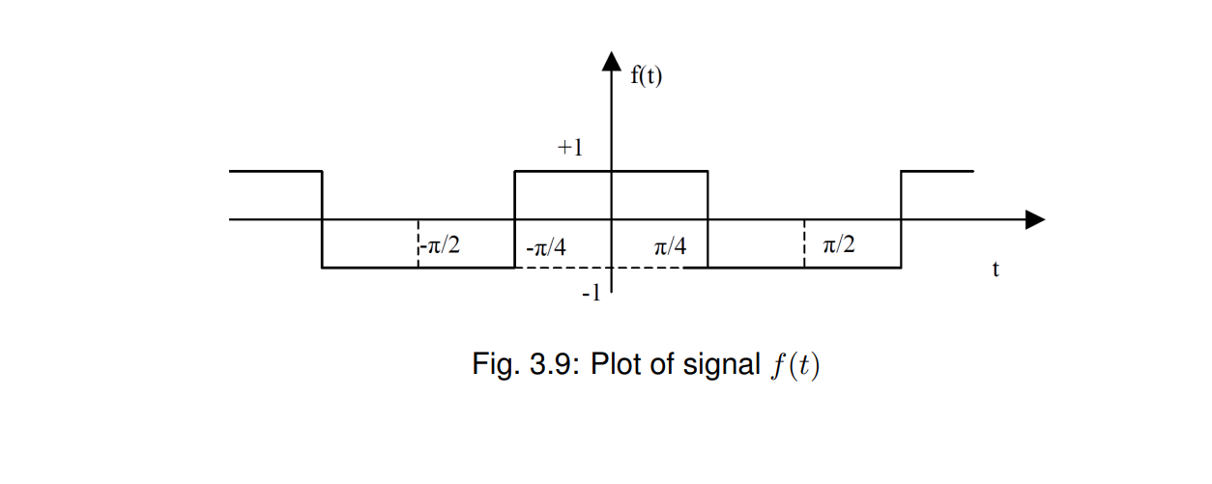

# **3.0 Experiment Procedure**

# 3.6.1 Sine Wave Procedure

The following is how we configured the function generator and the oscilloscope.

1. Set Function Generator to output 1 kHz with a Vpp of 0.5 V.
2. Set Function Generator output impedance to 50 Ohm.
3. Connect the output probes of the function generator to the oscilloscope.
4. Turn on function generator.
5. Preset & Auto-set oscilloscope.

The following is the screenshot of the time domain signal,

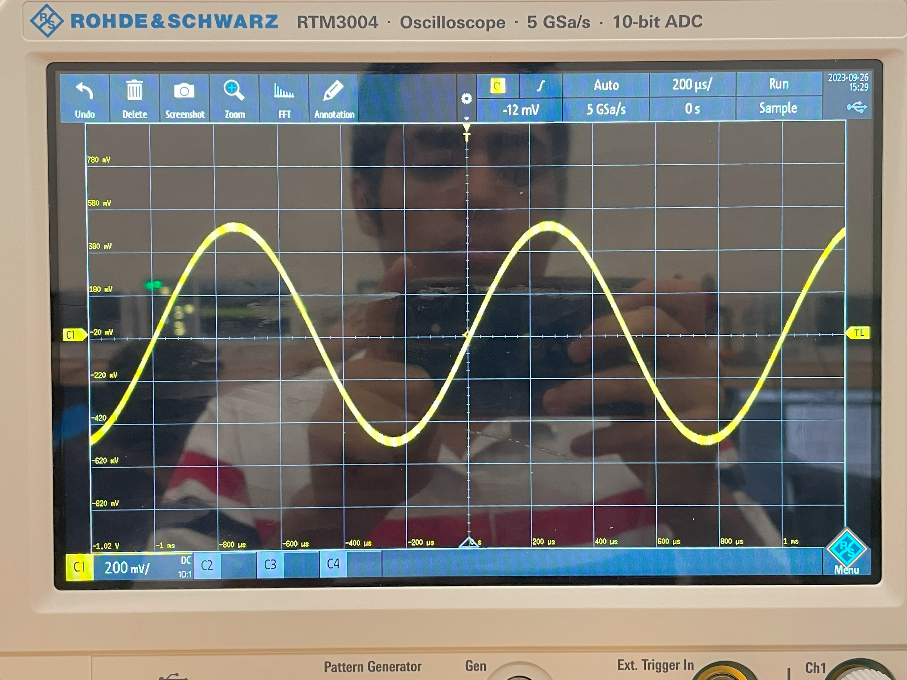

Afterwards, we viewed the frequency domain of the signal via the oscilloscope. The following is the FFT configuration,

1. Timebase = 2 seconds
2. Start Frequency = 0 Hz
3. Center Frequency = 1 kHz
4. Stop Frequency = 2 kHz

The following is a screenshot of the frequency domain signal,

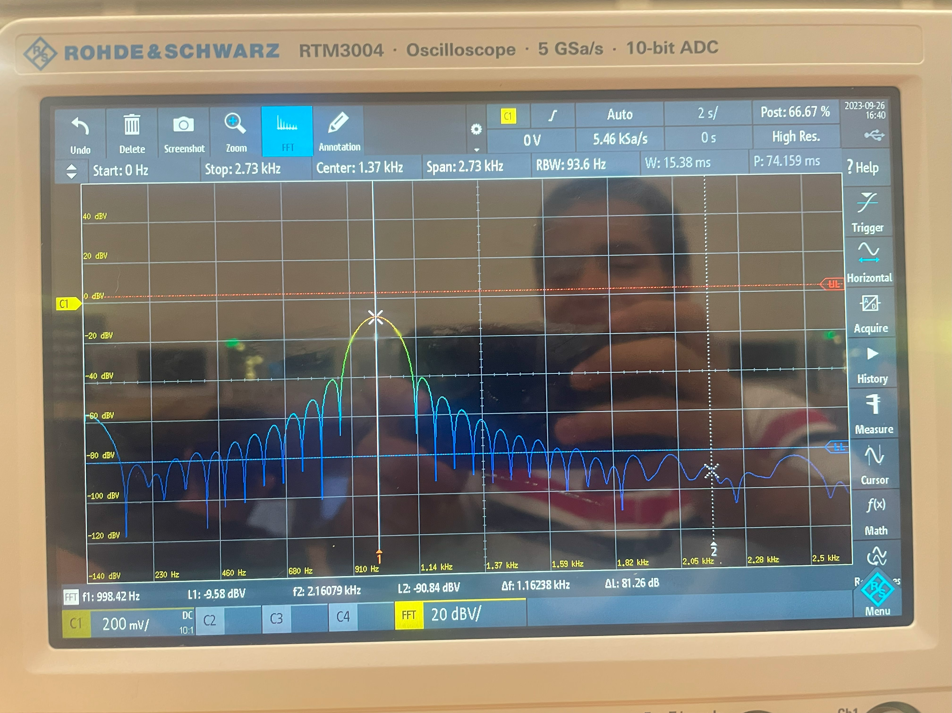

We repeated the previous measurements for another sinusoidal wave but with a frequency of 20 kHz. Since the frequency of the power signal has changed, we must also change the FFT configuration settings.

1. Timebase = 2 seconds
2. Start Frequency = 10 kHz
3. Center frequency = 20 kHz
4. Stop Frequency = 40 kHz

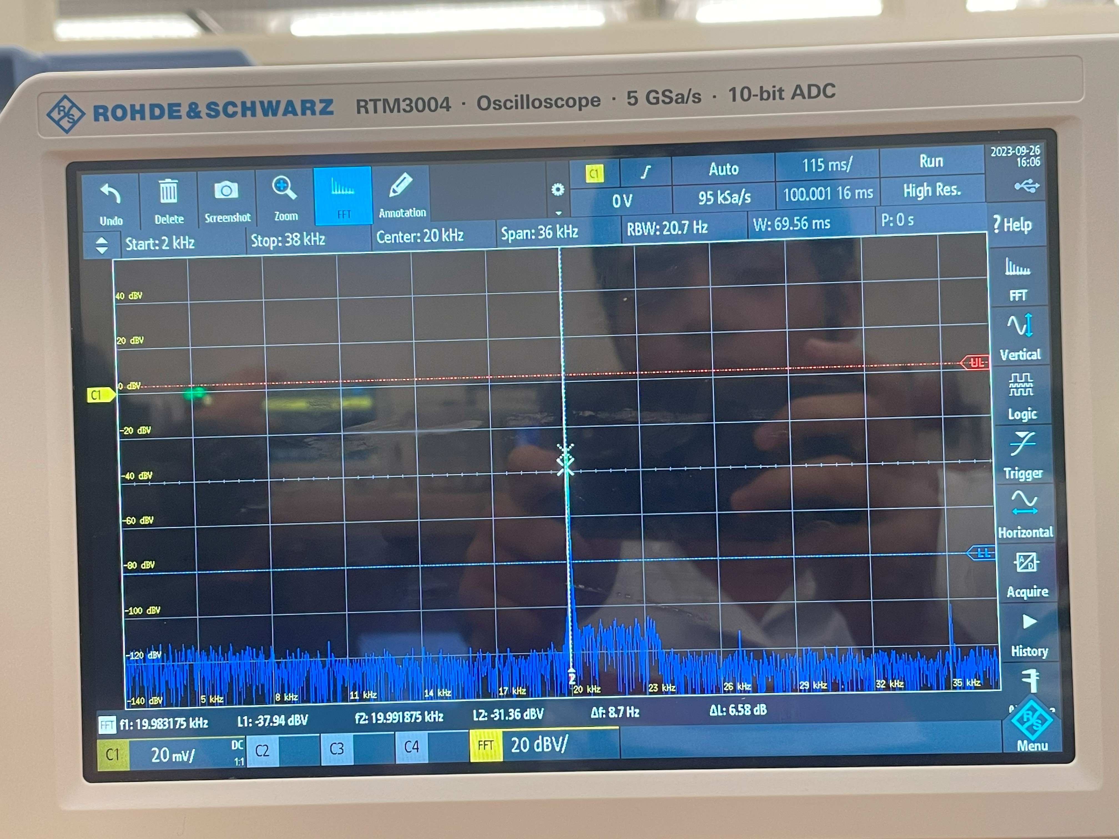

a. Explain why the window functions are needed, and explain the differences between the various functions. (For detailed information please see the RTC3004 manual)

b. Compare how each of the window functions affects the spectrum.

# 3.6.2 Square and Rectangular Waves

A rectangular based wave is a non-continuous function where the power signal oscillates between two voltage levels. An important parameter of rectangular wave is the duty cycle. The duty cycle determines the ratio of time between one voltage state compared to the other voltage reason.

To generate the square wave for this lab, we used the function generator with the following parameters:

1. Set frequency to 1 kHz.
2. Set output mode to pulse mode.
3. Set duty cycle to 50%.
4. Turn on function generator output.

The following is the frequency domain of the signal,

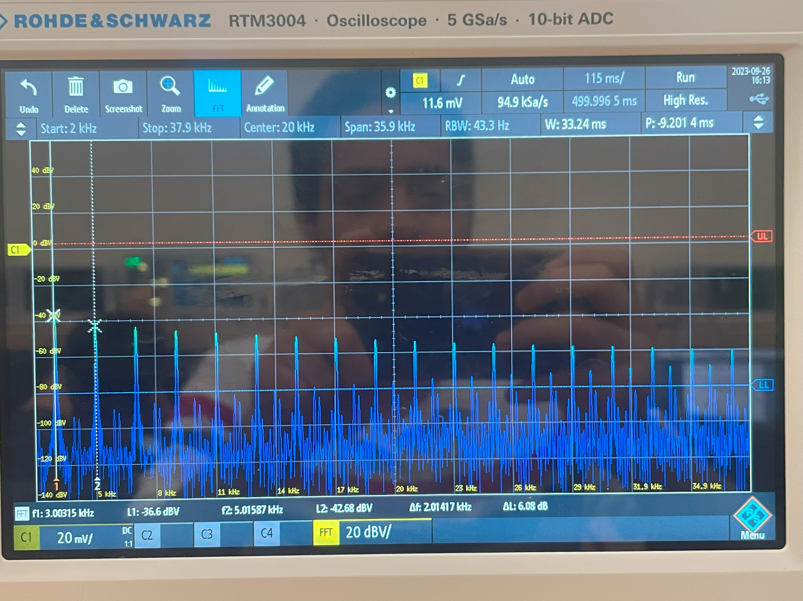

We repeated the measurement with 10% duty cycle:

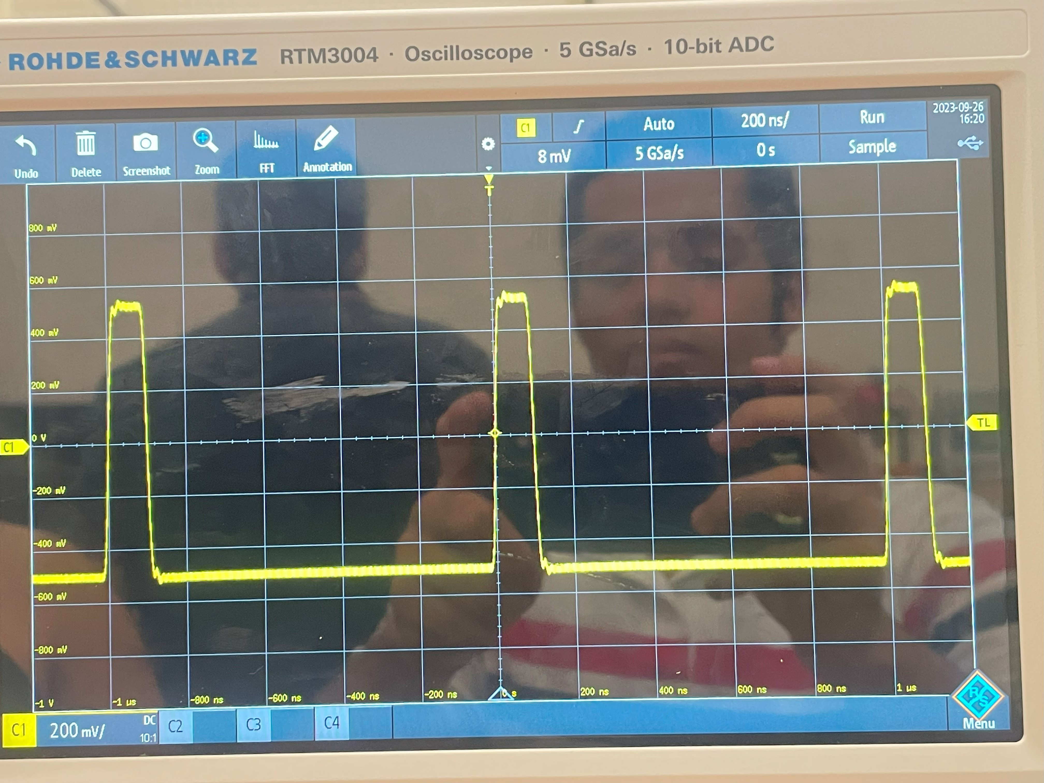

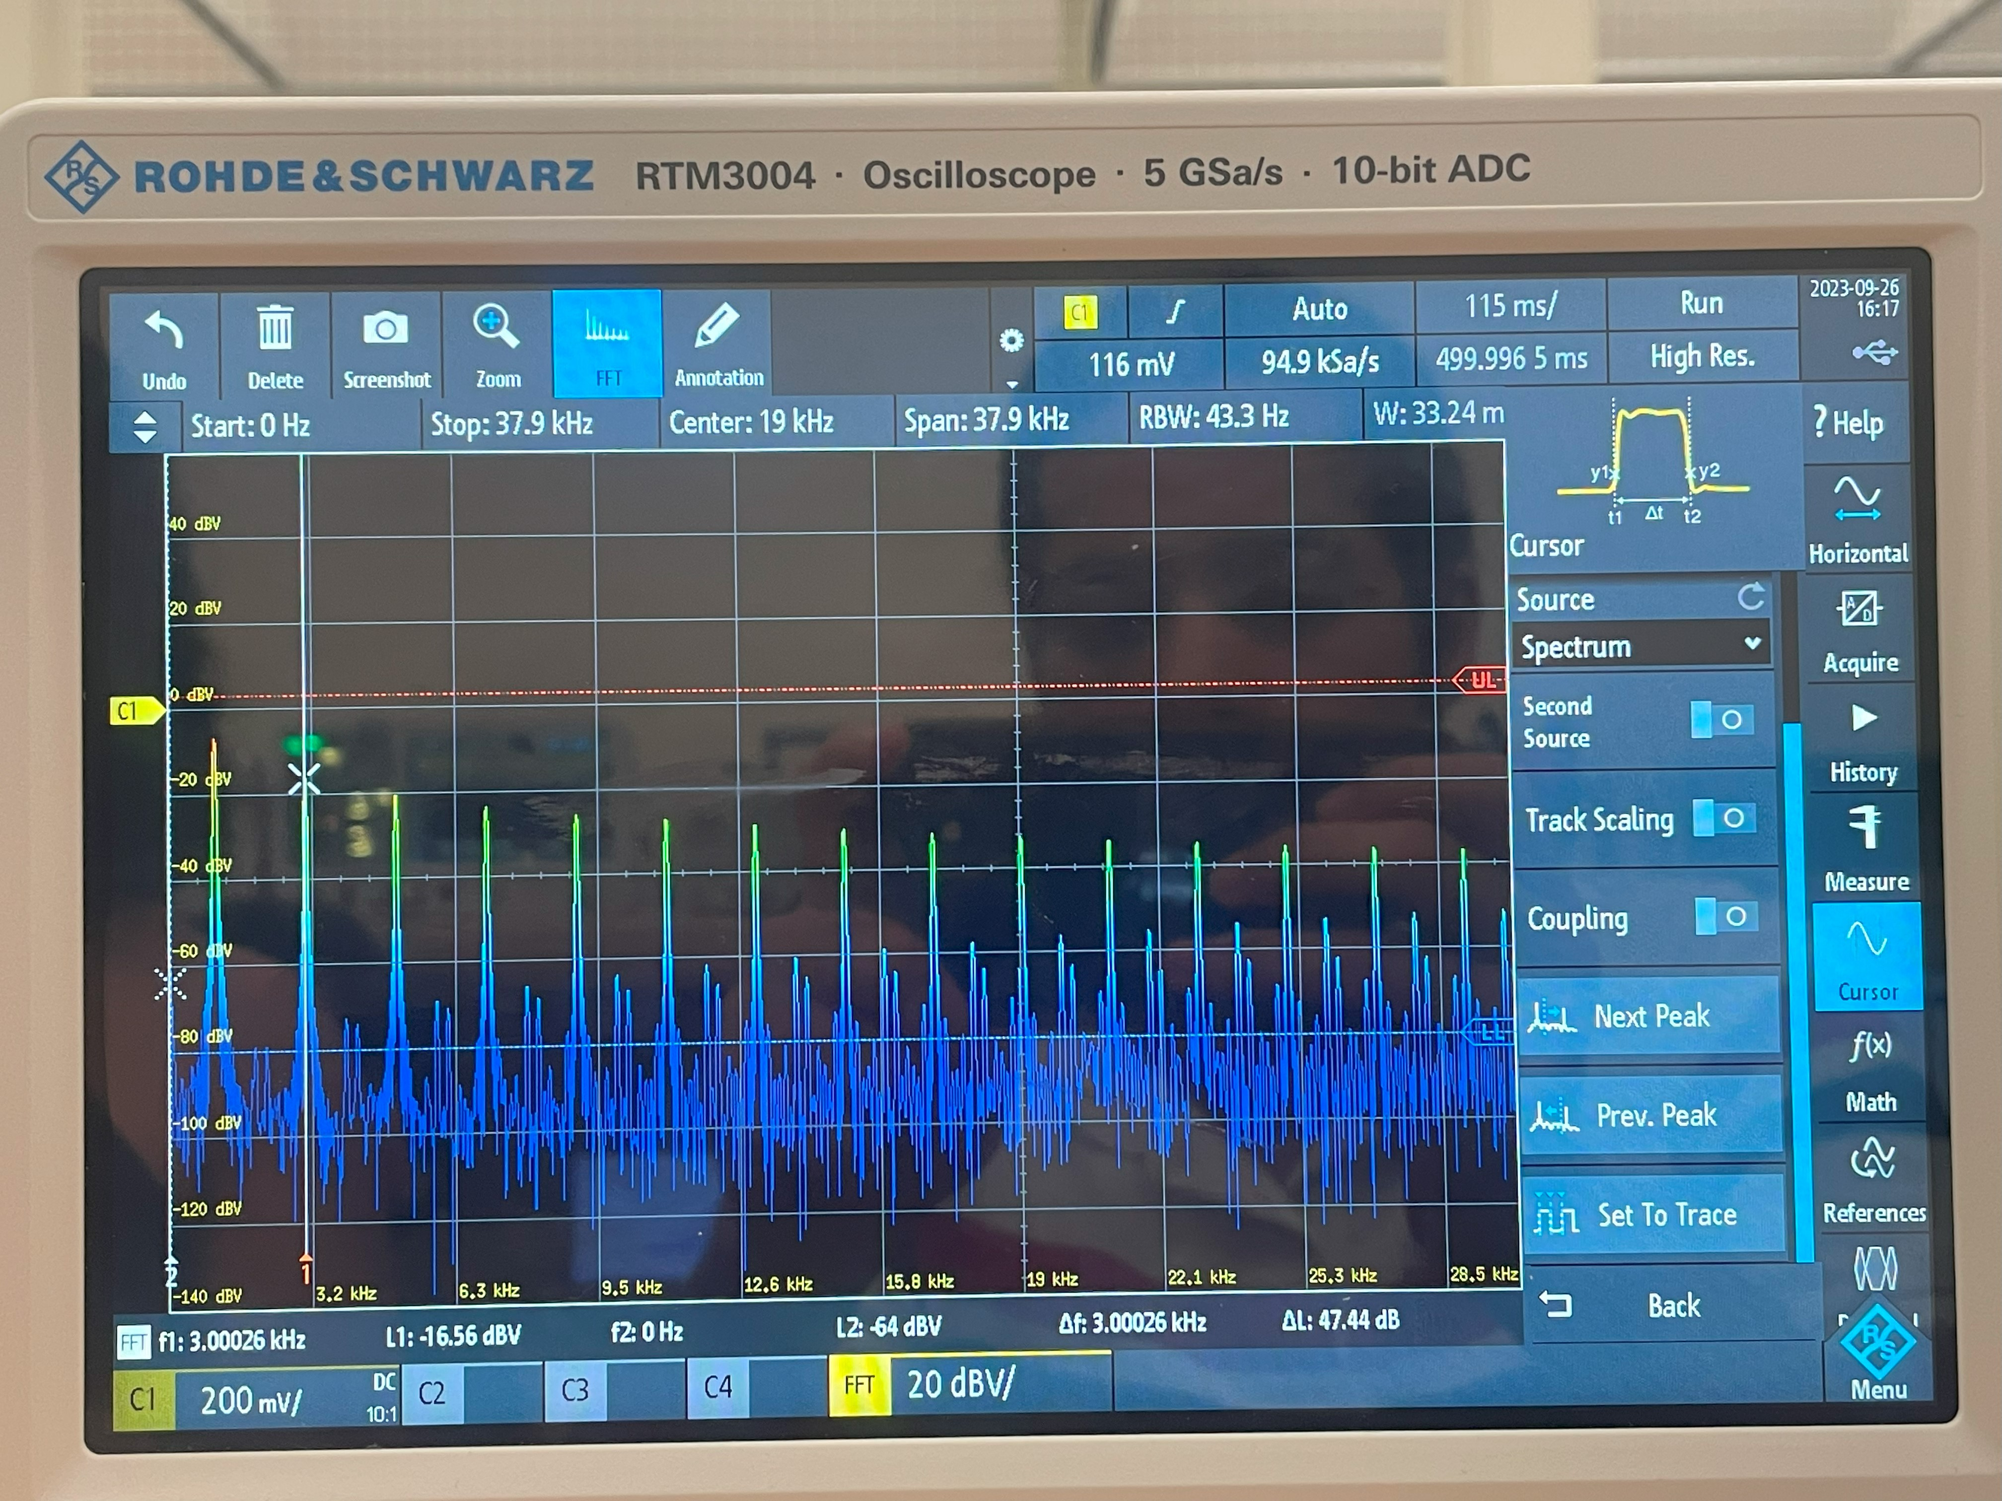

# 3.6.3 Triangular Wave

We repeated the measurement for the square wave but using a triangular wave instead.

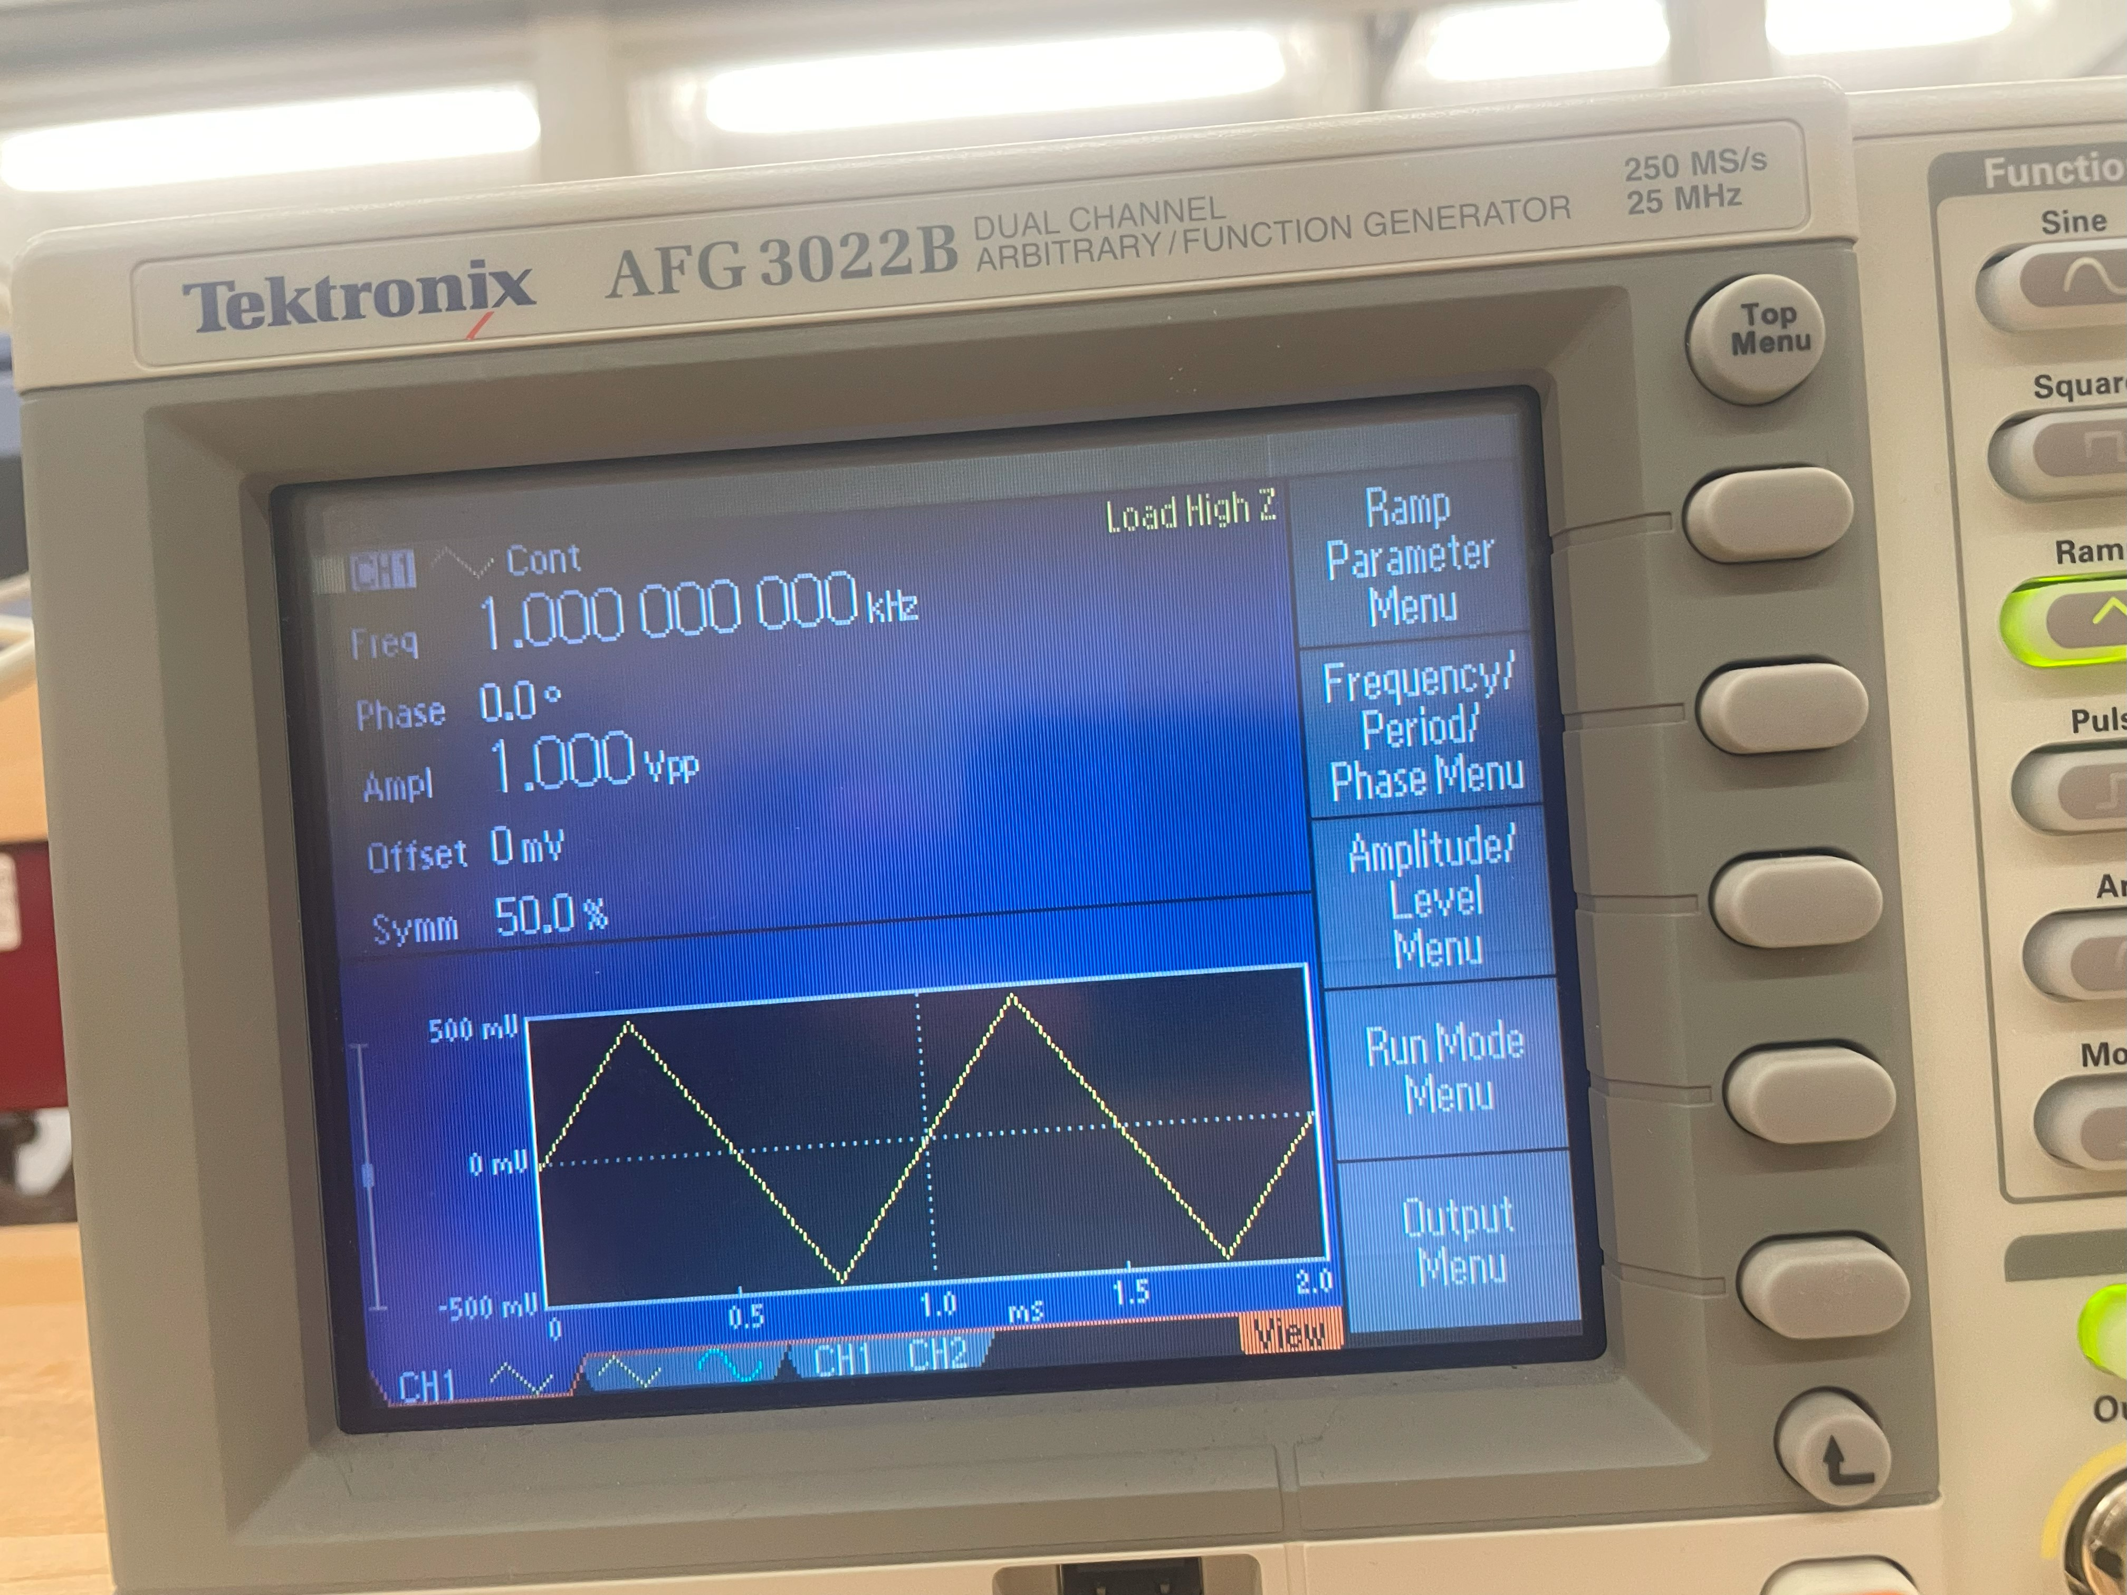

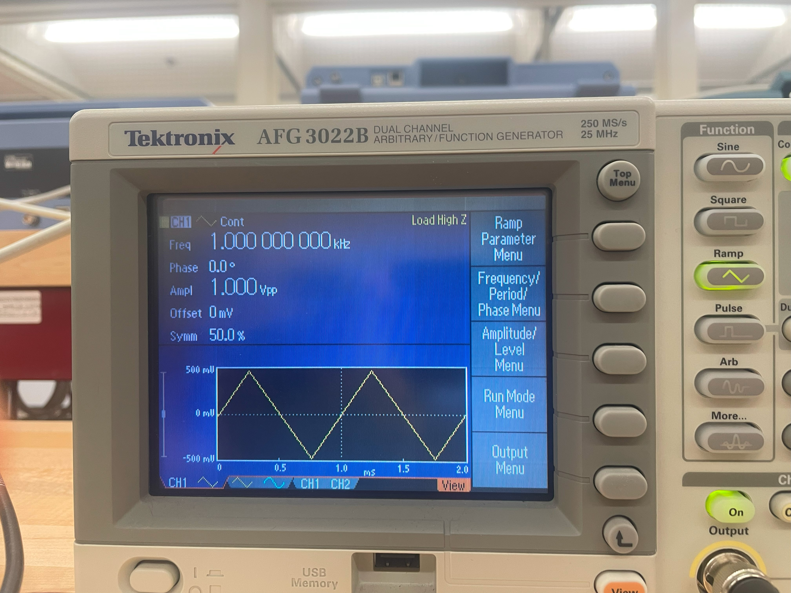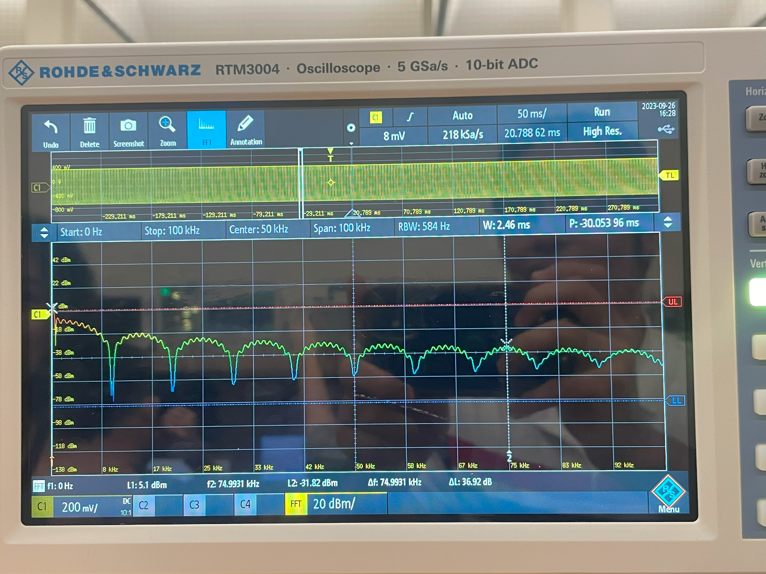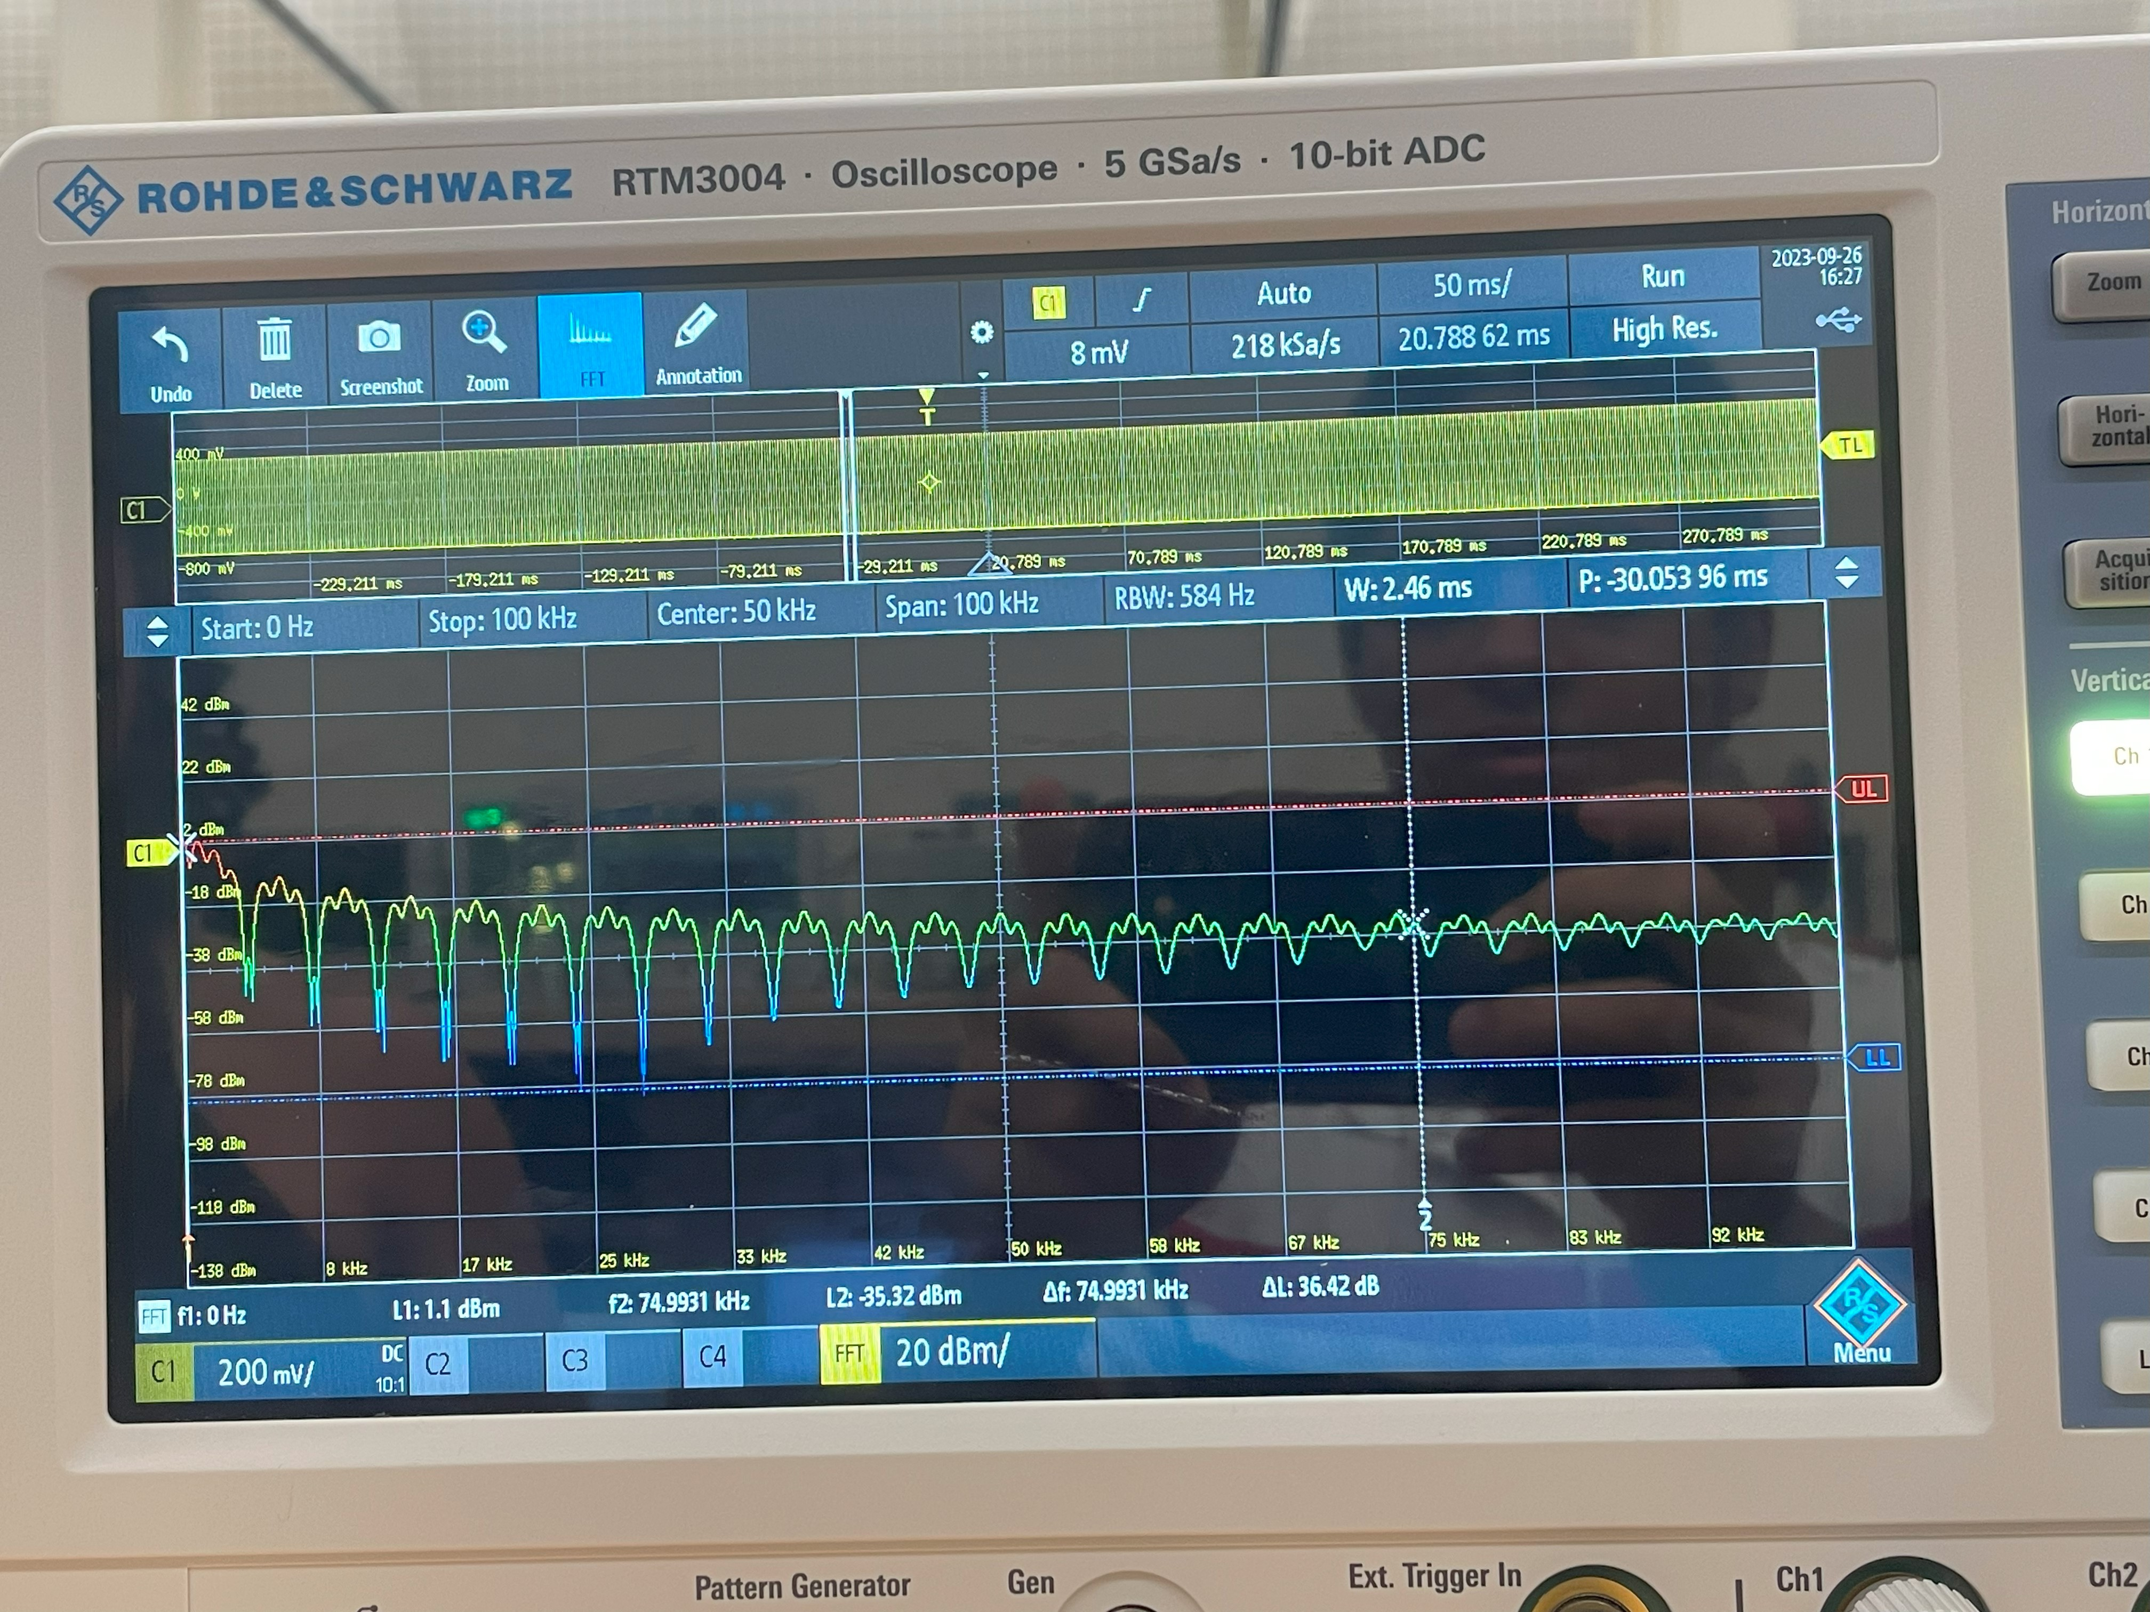

# **4.0 Observations and Simulation Comparison**

By generating square waves with varying duty cycles, we observed how changes in pulse width and signal frequency affected harmonic location, zero location, and peak spectrum amplitude. Our measurements demonstrated that duty cycle alterations can significantly impact the spectral content of square waves.

In the case of triangular waves, we repeated the measurements and observed their spectral characteristics. Notably, we found that the spectrum of a triangular wave can be related to the square of the spectrum of a square wave.

Lastly, we verified the expected spectral decay for square and triangular waves. The square wave's spectrum decayed proportionally to 1/ω (where ω = 2πf), while the triangular wave's spectrum decayed proportionally to 1/ω². Our measurements confirmed these relationships.

# **5.0 Learned Objectives**

* FFT Spectra.
* Triangle Wave.
* Square Wave.
* Duty Cycle.
* Windowing Modes

# **6.0 Conclusion**

Throughout this experiment, we achieved several learning objectives, including the ability to make differential voltage measurements using an oscilloscope, understanding concepts related to clamping and clipping circuits, exploring full-wave rectifiers, conducting simulations via LT-spice, and evaluating diode performance.

In conclusion, this experiment provided valuable insights into the analysis of periodic signals and their spectra. It allowed us to gain a deeper understanding of Fourier series, window functions, and the spectral characteristics of different waveforms. These concepts are essential in the field of signal analysis and analog communications, equipping us with the knowledge and skills necessary for further studies in this domain.